1.

%semilogplot

studentno=[15 25 55 115 144];

figure;

semilogy(studentno, 'ms', 'LineWidth', 4, 'MarkerSize', 10);

xlabel('years');

ylabel('log(number of students)');

title('nearly linear');

xlim([0, 6]);

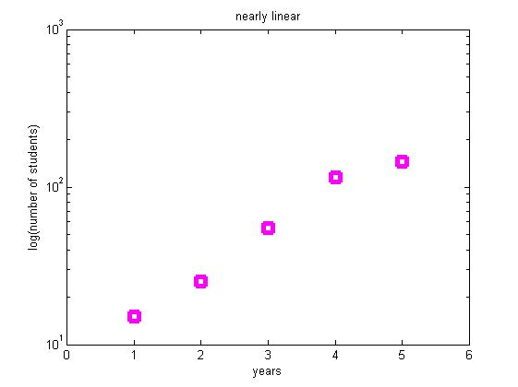

3.

%bar graph

bars=rand(1, 5);

figure;

bar(bars, 'r');

ylim([0, 1]);

title('Bar Graph of 5 Random Values');

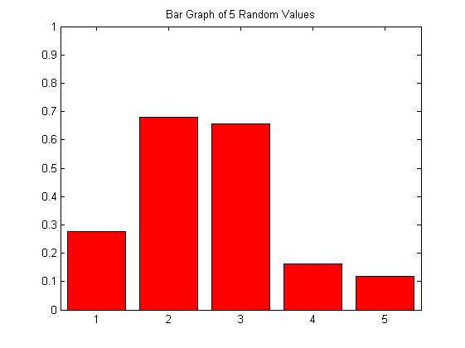

4.

%Interpolation and surface plots

n=5;

Z0=rand(n);

[X0, Y0]=meshgrid(1:n, 1:n);

[X1, Y1]=meshgrid(1:.1:n, 1:.1:n);

Z1=interp2(X0, Y0, Z0, X1, Y1, 'cubic');

figure;

surf(X1, Y1, Z1);

colormap hsv;

shading interp;

hold on;

contour(X1, Y1, Z1, 15);

colorbar;

caxis([0,1]);

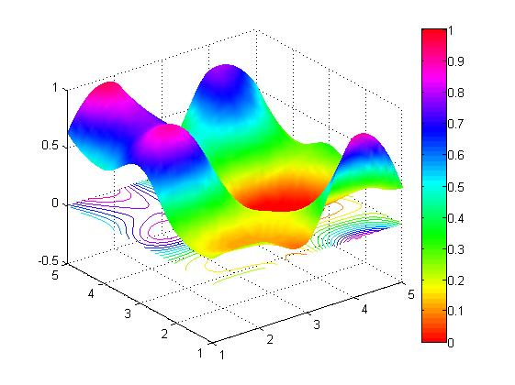

5.

function ind=findNearest(x, desiredVal)

%fun with find

kul2=abs(x-desiredVal);

mi=min(min(kul2));

[indsr, indsc]= find(kul2<mi+0.000000000000001); %valami számábrázolási szarság miatt

ind=[indsr, indsc];

end

6.

function loopTest(N)

%loops and flow control

for n=1:N

if mod(n,2)==0 && mod(n, 3)==0

str=[num2str(n) ' is divisible by 2 AND 3'];

elseif mod(n, 2)==0

str=[num2str(n) ' is divisible by 2'];

elseif mod(n, 3)==0

str=[num2str(n) ' is divisible by 3'];

else

str=[num2str(n) ' is NOT divisible by 2 or 3'];

end

disp(str);

end

end

7.

function smooted=rectFilt(x, width)

%smooting filter

smooted=zeros(1 , length(x));

if mod(width, 2)==0

str=[num2str(width) ' is not odd, instead of ' num2str(width) ', ' num2str(width+1) ' is used.'];

disp(str);

width=width+1;

end

window=(width-1)/2;

for n=1:length(x)

smooted(1,n)=mean(x(max(n-window, 1) : min(n+window, length(x))));

end

figure;

plot(x, 'bo', 'MarkerSize', 3, 'MarkerFaceColor', 'b');

hold on;

plot(smooted, '-r', 'LineWidth', 2);

title('Smoothing Illustration');

xlabel('Index');

ylabel('Data Value');

legend('Original Data', 'Smoothed');

end

