Infocommunication systems

List of questions

2019. január 8.

Ekart Csaba

Tartalomjegyzék

**1. What is the convergence in the field of information and communication technology? What are the consequences?** **3**

**2. Which kind of limits are in the field of electronic communications?** **3**

**3. What are the main transmission characteristics of twisted pair cables (Attenuation, characteristic impedance, crosstalk…)? What are the main applications of twisted pair cables?** **4**

**4. What are the main characteristics of coaxial cables? What are the main applications of coaxial cables?** **5**

**5. What are the main transmission characteristics and propagation modes of fiber cables? What are the main applications of fiber cables?** **6**

**6. What are the main transmission characteristics of radio connections? What is the fading?** **7**

**7. Which frequency bands are used in radio communications? What are the main wave propagation modes?** **7**

**8. What are the characteristics and main application of terrestrial and space radio communications?** **8**

**9. Principles of cellular systems** **9**

**10. Which frequency bands are used in satellite communications? What are the main communications problems in satellite communications?** **10**

**11. Analog modulation systems (AM-FM)** **11**

**12. Digital modulation systems (BPSK, QPSK, QAM)** **12**

**13. What are the main functions of multiplexing and switching nodes in the networks?** **13**

**14. What are the main features of circuit switching, packet switching and cell switching?** **14**

**15. Spread spectrum, FHSS, DSSS** **15**

**16. What is the network structure of the MATÁV network?** **17**

**17. What is the network structure of the PANTEL network?** **17**

**18. What are the main components of a GSM network?** **18**

**19. What are the operating statuses of a MS?** **19**

**20. What are the actions of the network during roaming and handover?** **20**

**21. What are the functions of HLR and VLR in the GSM network?** **21**

**22. What are the functions of MSC and BSC in the GSM network?** **21**

**23. What are the steps to call MS?** **22**

**24. What are the steps call from MS?** **22**

**25. What is the function of a private network?** **23**

**26. What are the function and structure of a CATV network?** **24**

**27. MPEG-2 principles** **24**

**28. What is the MPEG stream and transport stream?** **25**

**29. What is the structure of the HUNGARNET network? Why?** **25**

**30. Which technologies and structures are applied in the networks of ITK building?** **26**

**31. Principles of ADSL, Technology of ADSL, features of ADSL, VDSL** **26**

**32. What are the main service quality requirements in different services?** **27**

**33. What are the historical stages of regulation? What is the reason of competition instead of monopoly in electronic communication?** **27**

**34. What are the main functions of a terminal?** **28**

**35. Bluetooth, ZigBee** **28**

**36. WiFi principles, media access control, frequency bands, beamforming** **31**

**37. VoIP principles and versions** **32**

**38. IPTV** **33**

**39. Next generation networks** **33**

# 1. What is the convergence in the field of information and communication technology? What are the consequences?

* **Convergence in the field of information and communication:**
  + Telecom, Computer and Media industry slowly become one: Infocommunication.

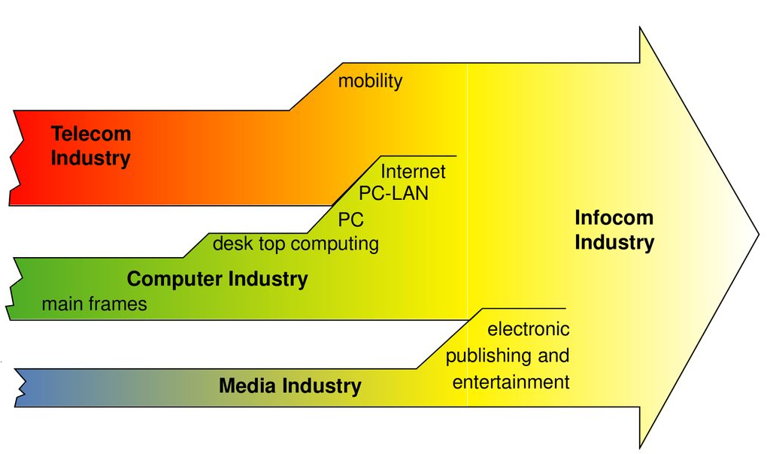

* **Convergence in networks:**
  + Traditionally separate networks and different technologies for telephone, for cable TV, for radio program broadcasting and data communications.
  + Today we make telephone calls on CaTV networks, on Internet, we access the Internet via telephone lines (ADSL) or using Mobile telephone networks
* **Convergence in terminals:**
  + Traditionally terminals were telephones, TV sets, computers, CD players etc.
  + Today we play MP3 songs on cell phones, watch TV programs on computers, edit files on mobile, read emails on the TV etc.

# 2. Which kind of limits are in the field of electronic communications?

* Main areas of the topic: storage, transmission, processing
* *“Is it cheaper a stored bit, a processed bit or a travelling bit?”*
* There are laws that describes the speed of the evolution in bandwidth, processing etc. (Moore law, Gilder law, Metcalf, etc.)
  + Moore law: The processing power doubling within 18 months.
  + **Gilder law**: The total bandwidth tripling within 12 months.
* Since Gilder law describes the fastest growing, the “winner” is transmission.
* Nowadays we are close to the **physical limits** in memories and processors.

# 3. What are the main transmission characteristics of twisted pair cables (Attenuation, characteristic impedance, crosstalk…)? What are the main applications of twisted pair cables?

* **Twisted pair cable**: Twisted pair cabling is a type of wiring in which two conductors of a single circuit are twisted together for the purposes of cancelling out electromagnetic interference (EMI) from external sources.
* **Attenuation**: Reduction in the strength of a signal. Unit: [dB]
* **Characteristic impedance**: Z0. The characteristic impedance of a transmission line is the ratio of the voltage and current of a wave travelling along the line. That is, a wave travelling in one direction in the absence of reflections in the other direction.[1]
* **Crosstalk**: In electronics, crosstalk is any phenomenon by which a signal transmitted on one circuit or channel of a transmission system creates an undesired effect in another circuit or channel.
* **NeXT**: Near-end Crosstalk. Interference between two pairs in a cable is measured at the same end of the cable as the interfering transmitter.
* **FeXT**: Far-end Crosstalk. Interference between two pairs of a cable measured at the other end of the cable with the respect to the interfering transmitter.

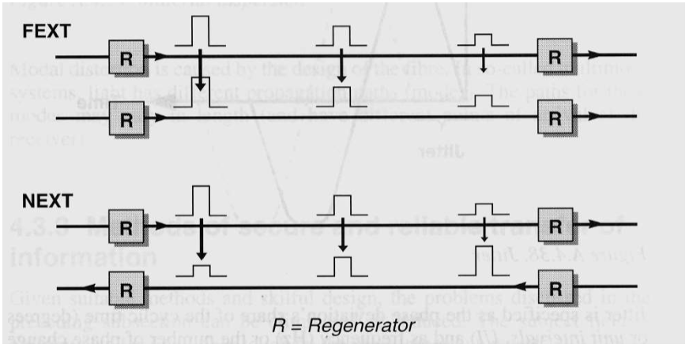

* **Main applications of twisted pair cable**: Ethernet cabling (UTP), phone networks, ADSL etc.

# 4. What are the main characteristics of coaxial cables? What are the main applications of coaxial cables?

* **Coaxial cable**: is a type of cable that has an inner conductor surrounded by a tubular insulating layer, surrounded by a tubular conducting shield.

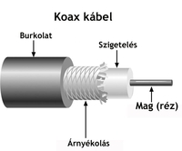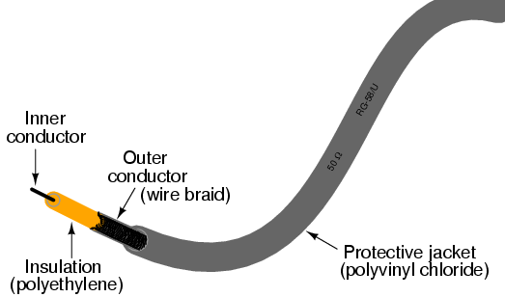

* **Characteristics**: Characteristics impedance, attenuation, velocity of propagation, peak voltage
  + **Velocity of propagation:** the ratio of the speed at which wavefront passes through the medium, to the speed of light in vacuum
  + **Peak voltage**: The peak voltage is set by the breakdown voltage of the insulator
* **Main applications**:
  + Often used to carry data and signals from an antenna to the receiver. (Satellite dish to a satellite receiver, television antenna to a television, radio mast to a radio etc.)
  + Short coaxial cables are commonly used to connect home video equipment, in ham radio (amateur radio) setups, measurement electronics.
  + Long distance coaxial cables were used in the 20th century to connect radio, television and phone networks.

# 5. What are the main transmission characteristics and propagation modes of fiber cables? What are the main applications of fiber cables?

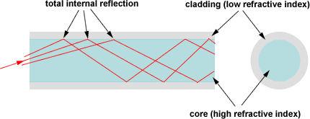

* An optical fiber or optical fibre is a flexible, transparent fiber made by drawing glass (silica) or *plastic*.[2]
* Optical fibers typically include a core surrounded by a transparent cladding material with a lower index of refraction.
* Light is kept in the core by the phenomenon of **total internal reflection** which causes the fiber to act as a waveguide.
* **Three key characteristics** of fiber optic waveguides can be affected by environmental conditions: **strength, attenuation and resistance to losses caused by microbending.**
* **Propagation modes**:[3] multi-mode step index (used on shorter distances), single-mode step index (used on longer distances), multi-mode graded index

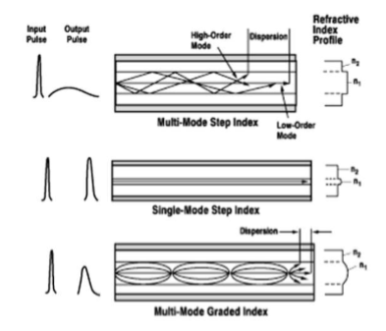

* **Intermodal dispersion**: the phenomenon that the group velocity of light propagating in a waveguide structure depends on the waveguide mode.
* Optical fibers are used most often as a means to transmit light between the two ends of the fiber and find wide usage in fiber-optic communications, where they permit transmission over longer distances and at higher bandwidths (data rates) than electrical cables.
* Concrete applications: <https://www.doityourself.com/stry/9-uses-of-fiber-optic-cables>

# 6. What are the main transmission characteristics of radio connections? What is the fading?

* **Path loss**: path loss or path attenuation is the reduction in power density of an electromagnetic wave as it propagates through space.
* **Delay**: The time difference in propagation between two signals which had taken different paths may interfere with reception, since the data streams that are received overlap with one another.
* **Fading**: In wireless communications fading is the deviation of the attenuation affecting a signal over certain propagation media. Fading may vary with time, geographical position and radio frequency, and is often modeled as a random process. A fading channel is a communication channel comparising fading. In wireless systems, fading may either be due to multipath propagation, referred to as multipath induced fading or due to shadowing from obstacles affecting the wave propagation, sometimes referred as shadow fading.

*A vezeték nélküli hírközlésben a többutas hullámterjedés által okozott jelenség, amelynek során a vételi térerősség véletlenszerűen erősödhet/gyengülhet, amelyet a vevőantennára különböző amplitúdókkal és fáziskülönbséggel érkező felületi és térhullámú jelek interferenciája okoz.*

* **Reflection**: When a radio wave hits an obstacle, some or all of the wave is reflected, with loss of intensity. Reflection is such that angle of incidence is equal to the angle of reflection.
* **Polarization**: *The ability of waves to oscillate in more than one direction.* Property of a radiated electromagnetic wave describing the time varying direction and relative magnitude of the electric-field vector. In general, the field is elliptically polarized.
* **Reliability and availability** - equipment and propagation parameters (lightning, snow, rain, fog smoke)

# 7. Which frequency bands are used in radio communications? What are the main wave propagation modes?

* **Used frequency bands**:
  + Low Frequency: LF (30 - 300 kHz)
  + Medium Frequency: MF (300 - 3000 kHz)
  + High Frequency: HF (3 - 30 MHz)
  + Very High Frequency: VHF (30-300 MHz)
  + Ultra High Frequency: UHF (300-3000 MHz)
  + Super High Frequency: SHF (centimetric waves, 3 - 30 GHz)
  + Extremely High Frequency: EHF (millimetric waves, 30 - 300 GHz)
* **Propagation modes:**
  + Ground wave propagation (below 2 MHz)

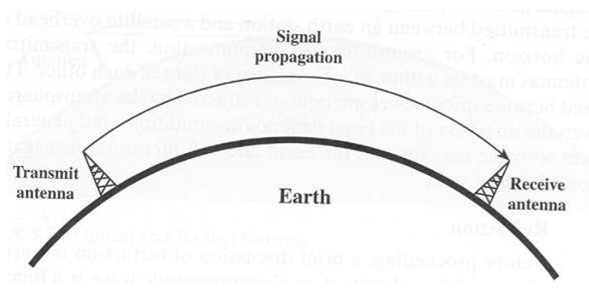

* + Sky wave propagation (2 to 30 MHz)

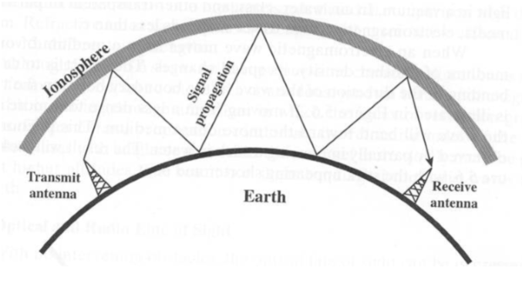

* + Line-of-Sight propagation (above 30 MHz)

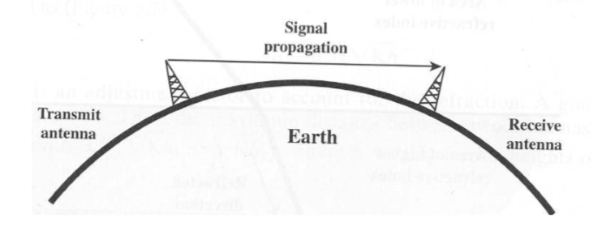

# 8. What are the characteristics and main application of terrestrial and space radio communications?

* **Radio link types:**
  + point-to-point connection
  + point-to-multipoint connection
  + cellular system
* **Earth orbit altitudes:**
  + Low Earth Orbit (LEO): 500 - 1500 km
    - Low loss, low delay, but not fixed position
  + Medium Earth Orbit (MEO): 5000 - 12000 km
  + Geostationary Earth Orbit (GEO): 36000 km
* **Characteristics:**
  + Transmission parameters (path loss, delay, fading, reflection, polarization)
  + Reliability and availability (lightning, snow, rain, etc.)
  + Privacy
* A **geosynchronous satellite** is a satellite in geosynchronous orbit, with an orbital period the same as the Earth's rotation period.
* The **footprint** of a communications satellite is the ground area that its transponders offer coverage, and determines the satellite dish diameter required to receive each transponder's signal.
* **Main applications:**
  + As compared to the terrestrial media, particularly the optical fiber, the bandwidth supported by satellites is much less. So in most cases if it’s available we use it.
  + Satellites however has much wider cover, when this has more importance we prefer that, eg. GPS
  + **Geosynchronous satellites**: global communications, television broadcasting and weather forecasting, and have a number of important defense and intelligence applications.

# 9. Principles of cellular systems

* A **cellular network** or mobile network is a communication network where **the last link is wireless**. The network is distributed over land areas called cells, each served by at least one fixed-location transceiver, but more normally three cell sites or base transceiver stations. These base stations provide the cell with the network coverage which can be used for transmission of voice, data, and other types of content.
* A cell typically uses a different set of frequencies from neighboring cells, to avoid interference and provide guaranteed service quality within each cell.
* In the cellular concept frequencies allocated to the service are re-used in a regular pattern of areas, called “cells”, each covered by one base station. In mobile telephone networks these cell are usually hexagonal.
* **Notations**:
  + In a cluster each cell has a separate frequency
  + a: the area of one cell
  + A: the cluster area
  + R: the cell diameter
  + D: the distance between clusters (cells with identical frequencies)
  + K: number of cluster cells.

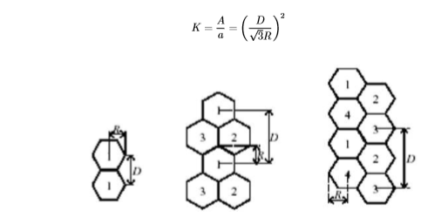

* **Increasing capacity in cellular systems**
  + Adding new channels
  + Frequency borrowing
  + Cell splitting
  + Cell sectoring
  + Microcells

# 10. Which frequency bands are used in satellite communications? What are the main communications problems in satellite communications?

* **Frequency bands for satellite communications:**

| **Band** | **Frequency range** | **Total bandwidth** | **General application** |
| --- | --- | --- | --- |
| L | 1 - 2 GHz | 1 GHz | Mobile satellite service (MSS) |
| S | 2 - 4 GHz | 2 GHz | MSS, NASA, deep space research |
| C | 4 - 8 GHz | 4 GHz | Fixed satellite service (FSS) |
| X | 8 - 12.5 GHz | 4.5 GHz | FSS military, terrestrial earth exploration,  and meteorological satellites |
| Ku | 12.5 - 18 GHz | 5.5 GHz | FSS, broadcast satellite service (BSS) |
| K | 18 - 26.5 GHz | 8.5 GHz | BSS, FSS |
| Ka | 26.5 - 40 GHz | 13.5 GHz | FSS |

* **Main problems in satellite communications:**
  + **High propagation delay:**
    - Could results in echo and talker overlap
    - Causes problems for many data communication protocols such as TCP/IP. Special protocols need to be designed for data communication networks that use satellites.
  + **Low bandwidth:** 
    - As compared to the terrestrial media, particularly the optical fiber, the bandwidth supported by satellites is much less.
    - Though present satellites provide much more bandwidth than the satellites of the 1970s and 1980s, the bandwidth is nowhere comparable to the optical fiber bandwidth.
  + **Noise:**
    - Satellite channels are affected by rain, atmospheric disturbances, etc. As a result, the performance of satellite links is generally poor as compared to terrestrial links.
    - If data is received with errors, the data has to be retransmitted by the sender. To reduce retransmissions, forward error correcting (FEC) codes are implemented.

# 11. Analog modulation systems (AM-FM)

* **AM: Amplitude modulation.** The momentary amplitude of the carrier is proportional to the momentary amplitude of the modulating signal.  
  *Az amplitúdó moduláció (rövidítve: AM) a jelátvitelben az amplitúdó változtatása, mely ezáltal az átviendő információt hordozza.*

**

* **FM: Frequency modulation.** The momentary frequency of the carrier is proportional to the momentary amplitude of the modulating signal.

*A frekvenciamoduláció (rövidítve: FM) a jelátvitelben a frekvencia változtatása, mely ezáltal az átviendő információt hordozza.*

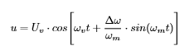

* Comparison:
  + AM is a completely analog system, and its very old
  + AM advantages: works on longer distance, ionosphere can reflect the signal
  + FM advantages: it can produce higher bandwidth, clearer sounds, and much less sensitive to interference

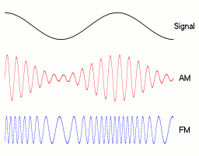

# 12. Digital modulation systems (BPSK, QPSK, QAM)

* **Phase-Shift Keying (PSK):** digital modulation scheme that conveys data by changing, or modulating, the phase of a reference signal (the carrier wave).
* **Binary Phase-Shift Keying (BPSK):** the simplest form of phase shift keying. It uses two phases which are separated by 180°.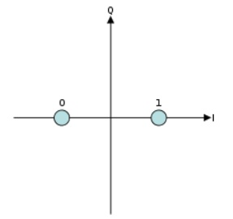
  + It does not particularly matter exactly where the constellation points are positioned.
  + This modulation is the most robust of all the PSKs, since it takes the highest level of noise or distortion to make the demodulator reach an incorrect decision.
  + It is, however, only able to modulate at 1 bit/symbol and so is unsuitable for high data-rate application.

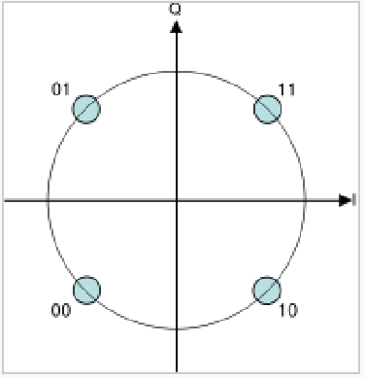

* **Quadrature Phase-Shift Keying (QPSK):** uses four points of the constellation diagram, equispaced around a circle.
  + With four phases QPSK can encode two bits per symbol to minimize the bit error rate.
  + The mathematical analysis shows that QPSK can be used either double the data rate compared with a BPSK system while maintaining the same bandwidth or to maintain the data rate but halving the bandwidth needed.
  + Application: Mobile networks, GSM (because of higher data-rate, but still pretty hard to reach an incorrect decision)
* **Quadratic Amplitude Modulation (QAM):** both an analog and a digital modulation scheme. It conveys two analoge message signals by changing the amplitudes of two carrier waves, using Amplitude-Shift Keying (ASK) digital modulation scheme or amplitude modulation (AM) analog modulation scheme.
  + Two carriers: sine wave (Q), cosine wave (I)
  + The modulated signal is the sum of the two components.
  + Different amplitude and different phase values for one symbol.
  + 16QAM means: one symbol is four bits.
  + Application: Internet connections (where high data-rate is important)

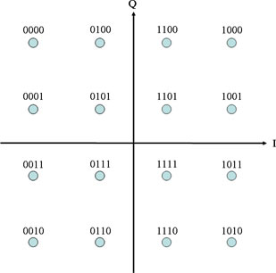

# 13. What are the main functions of multiplexing and switching nodes in the networks?

* **Multiplexing:** In telecommunications and computer networks, multiplexing (sometimes contracted to muxing) is a method by which multiple analog or digital signals are combined into one signal over a shared medium.
  + **Several telephone calls may be carried using one wire.**
  + Time-division Multiplexing (TDM)
  + Frequency-division Multiplexing (FDM)
  + Code Division Multiple Access (CDMA)
  + Wavelength Division Multiplexing (WDM)
* **Switching**: in the telecommunications industry, switching is used to connect two nodes that are not in direct proximity to each other.
  + Nodes are endpoints or redistribution points that receive and send data across distributed networks.
  + Switches connect these nodes to ensure seamless communication across devices which are not physically close or connected. This ability to quickly and accurately distribute the right information to the proper node so that is reaches the end user in a digestible way is why switching is so important.
  + There are two main types of switching in use in telecom today:
    - **Circuit switching**: in this method, the nodes determine a dedicated path over which they will communicate. This ensures optimal bandwidth use.
    - **Packet switching**: In packet switching the transmitted message is broken into parcels, or packets each of which are informed by a destination address. This method allows for many transmissions to use the same path.
* **Main functions:**
  + To reduce transmission costs
  + To utilize higher bandwidth
  + Framing and packing information

# 14. What are the main features of circuit switching, packet switching and cell switching?

* **Circuit switching** is a method of implementing a telecommunications network in which two network nodes establish a dedicated communications channel (circuit) through the network before the nodes may communicate.
  + The circuit guarantees the full bandwidth of the channel and remains connected for the duration of the communication session.
  + The circuit functions as if the nodes were physically connected as with an electrical circuit.
  + The defining example of a circuit-switched network is the early analog telephone network. When a call is made from one telephone to another, switches within the telephone exchanges create a continuous wire circuit between the two telephones, for as long as the call lasts.
  + **Advantage**: it provides for **continuous transfer** without the overhead associated with packets, making **maximal use of available bandwidth** for that communication.
  + **Disadvantage**: it can be **relatively inefficient**, because unused capacity guaranteed to a connection cannot be used by other connections on the same network.
* **Packet switching** is a method that groups all transmitted data into suitably sized blocks (packets), which are transmitted via a medium that may be shared by multiple simultaneous communication session.
  + In packet switching, instead of being dedicated to one communication session at a time, network links are shared by packets from multiple competing communication sessions, resulting in the loss of the quality of service guarantees that are provided by circuit switching.
  + Packet switching is the primary basis for data communications in computer networks worldwide.
  + Packet switching increases network efficiency, robustness and enables technological convergence of many applications operating on the same network.
  + Connection-oriented
  + Connectionless
* **Cell switching** is associated with **Asynchronous Transmission Mode (ATM)**
  + Asynchronous Transfer Mode (ATM) is, according to the ATM Forum, "a telecommunications concept defined by ANSI and ITU (formerly CCITT) standards for carriage of a complete range of user traffic, including voice, data, and video signals".
  + ATM uses asynchronous time-division multiplexing, and encodes data into small, fixed-sized packets (ISO-OSI frames) called cells.
  + This differs from approaches such as the Internet Protocol or Ethernet that use variable sized packets and frames.
  + Fixed cell length

# 15. Spread spectrum, FHSS, DSSS[4]

* **Spread spectrum:** in telecommunication and radio communication, spread-spectrum techniques are methods by which a signal (e.g. an electrical, electromagnetic or acoustic signal) generated with a particular bandwidth is deliberately spread in the frequency domain, resulting a signal with a wider bandwidth.
  + These techniques are used for variety of reasons, including the establishment of secure communications, increase resistance to natural interference, noise and jamming, to prevent detection, and to limit power flux density (e.g. in satellite downlinks).

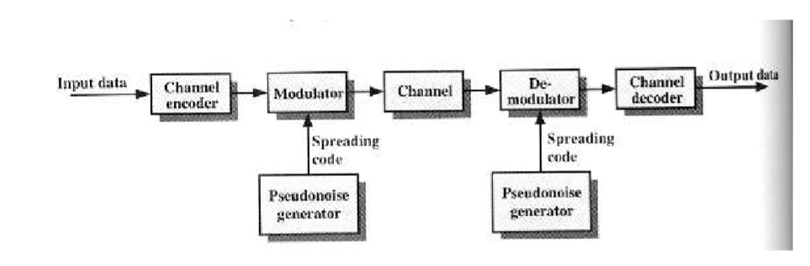

* **Frequency Hopping Spread Spectrum (FHSS):** a method of transmitting radio signals by rapidly switching a carrier among many frequency channels, using a pseudorandom sequence known to both transmitter and receiver.
  + A number of channels are allocated for FH.
  + The transmitter operates in one channel at a time for fixed time interval (Tc)
  + During that interval some number of bits or a fraction of a bit are transmitted (signal elements)
  + The time interval of signal elements Ts
  + The sequence of the channels used is dedicated by spreading code
  + Both transmitter and receiver use the same code to tuhe into a sequence of channels in synchronisation.
* **FHSS transmitter and receiver:**

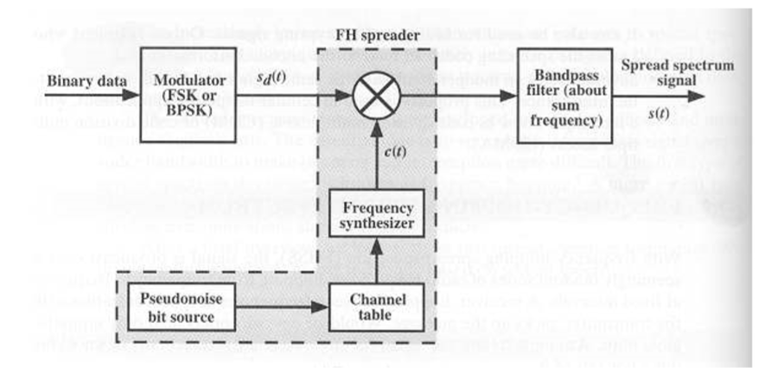

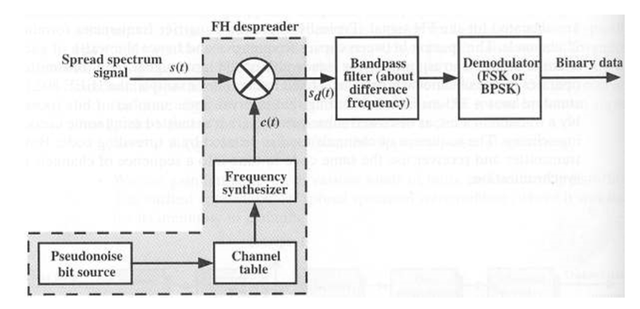

* **Direct Sequence Spread Spectrum (DSSS)** transmissions multiply the data being transmitted by a noise signal.
  + This noise signal is a pseudorandom sequence of 1 and -1 values, at a frequency much higher than that of the original signal. The resulting signal resembles white noise, like an audio recording of “static”.
  + This noise-like signal is used to exactly reconstruct the original data at the receiving end, by multiplying it by the same sequence. (1 x 1 = 1, -1 x -1 = 1)

# 16. What is the network structure of the MATÁV network?[5]

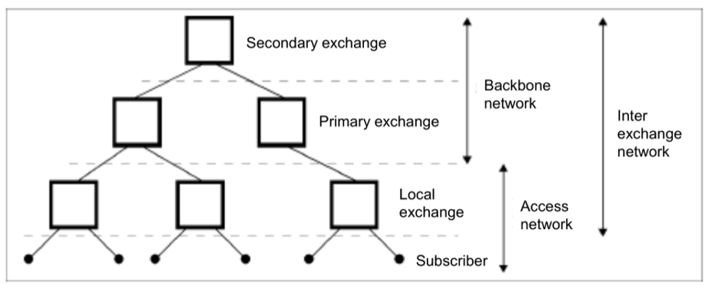

* **Backbone networks**: long distances, high traffic, interconnection of nodes, transport bits of any services, high reliability, high availability.
* **Access networks**: local distances, interconnection of terminals and local nodes
* Basic network structures in PSTN networks:
  + **Star topology**
  + Multipolar topology
  + Meshed topology
  + Ring topology
  + Bus topology

# 17. What is the network structure of the PANTEL network?

* PANTEL network nodes and interconnections (optical air cables) follow the railway. MÁV is a shareholder in it.
* This backbone network is divided into 5 main SDH rings.

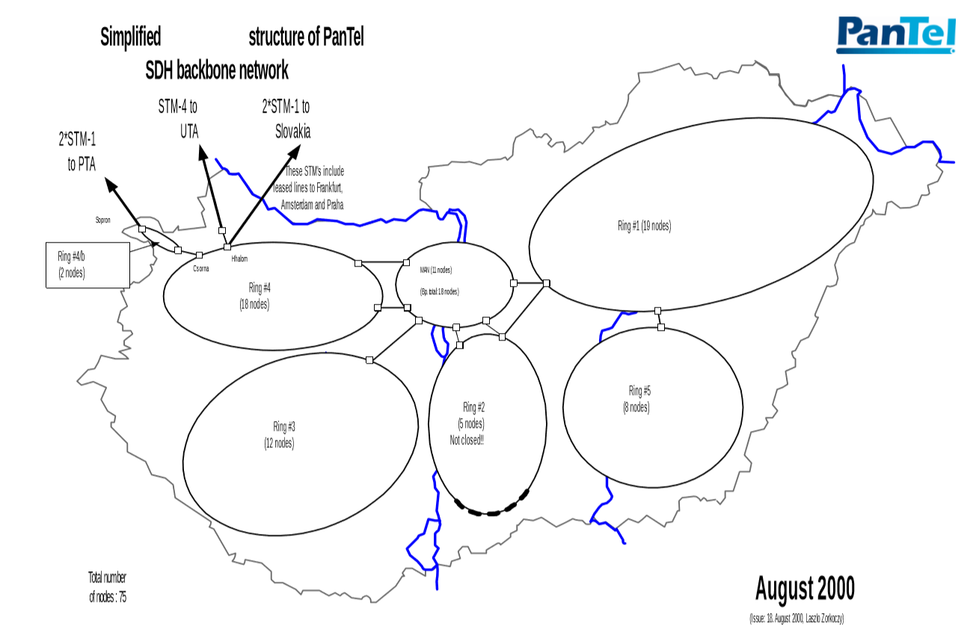

# 18. What are the main components of a GSM network?[6]

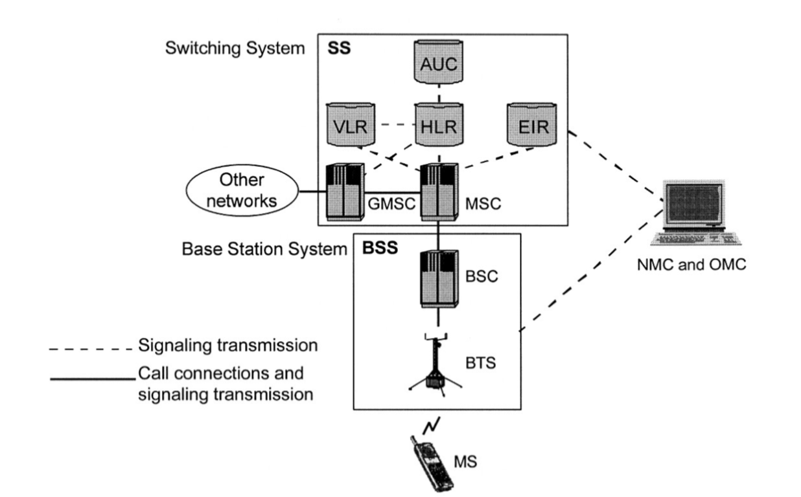

* **Switching system**
  + **HLR**: Home Location Register[7]
  + **AUC**: Authentication Center
    - The AUC is to authenticate subscribers attempting to use a network
  + **VLR**: Visitor Location Register
  + **EIR**: Equipment Identity Register
    - Database to block calls from stolen, unauthorized or defective MSs.
  + **MSC**: Mobile Switching Center
  + **GMSC**: Gateway Mobile Switching Center
* **Base Station System**
  + **BSC**: Base Station Controller
  + **BTS**: Base Transceiver Station
* **OMC**: Operations and Maintenance Centre
  + A computer system
  + Connected to MSCs and BSCs via data links
  + Shows information on the status of the network
  + Control system parameters
  + For short term, regional issues
* **NMC**: Network Management Centre
  + Centralized Control of a network
  + For long term system wide issues

# 19. What are the operating statuses of a MS?

* **Mobil station (MS)**
  + Used by mobile subscriber to communicate with the network
  + Consist of mobile terminal and **Subscriber Identity Module (SIM)**
  + Subscription is separated from the mobile terminal
  + Subscription information is stored in a “smart card”
  + Hand-held MS, Car-installed MS
* **MS states**
  + **Idle**: the MS is ON but a call is not in progress
  + **Active**: The MS is ON and a call is in progress
  + **Detached**: The MS is OFF
* **Idle key terms**
  + **Registration**: MS informs a network that is attached
  + **Roaming**: MS moves around the network in idle mode
  + **International Roaming**: MS moves into a network which is not its home network
  + **Location Updating**: MS inform the network when enters in new LA
  + **Locating**: BSC function to suggest connection to another cell based on MS measurement reports
  + **Paging**: The network tries to contact an MS by broadcasting message containing MS identity
* **Active key terms**
  + **Handover**: Process, where a call is switched from one physical channel to another, while MS moves around
* **MS registration**
  + MS power ON
  + MS scans for control channel frequencies
  + MS measures signal levels and records it
  + MS tunes to the strongest frequency
  + MS register to the network
  + Network update the MS status to idle
  + Network store location information
* **MS roaming**: the idle MS moves through the network, scan the control channels, tune to the strongest channel, in new LA inform the network of its new location.

# 20. What are the actions of the network during roaming and handover?

* **Roaming**: The idle MS moves through the network.
  + Scan the control channels
  + Tune to the strongest channel
  + In new Location Area (LA) informs the network of its new location.
* **Mobile Station Roaming Number (MSRN)**
  + Country Code (CC) (36 for Hungary)
  + National Destination Code (NDC) (20 for Telenor)
  + SN service Node
* **Basic Handover:**

1. BSC send handover-required message to the MSC
2. The MSC ask the target MSC to assist. The target MSC allocates a handover number that reroutes the call
3. A handover request is sent down to the new BSC
4. The BSC tells the new BTS to activate TCH
5. The MSC receives the information about the new Traffic Channel
6. The MSC passes info on new TCH from new BSC
7. A speech path to the new MSC is set up
8. A handover command goes to the MS with frequency and time slot data in the new cell
9. The MS sens handover burst on the new TCH
10. The target MSC is informed that the handover successful
11. A new path in the Group Switch is set up

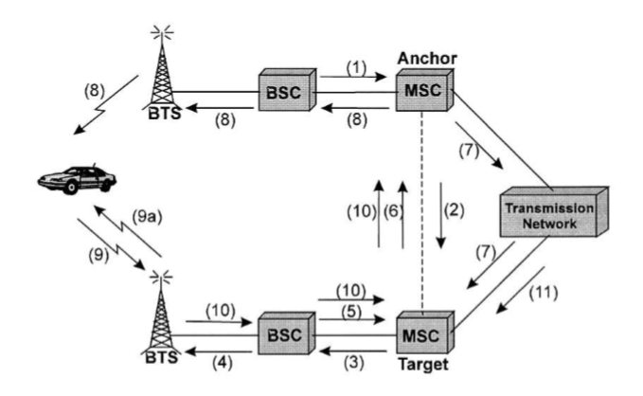

# 21. What are the functions of HLR and VLR in the GSM network?[8]

* **Home Location Register (HLR):** Centralized network database to store:
  + Subscriber identification
  + Subscriber supplementary services
  + Subscriber location information
  + Subscriber authentication information
* **Visitor Location Register (VLR):** 
  + Information about subscriber located in an MSC service area (a copy of HLR information)

# 22. What are the functions of MSC and BSC in the GSM network?

* **Base Station Controller (BSC)**
  + Manages all the radio related functions of the network
  + MS handover
  + Radio channel assignment
  + Collection of cell configuration data
  + Controlled by MSC
* **Mobile Switching Center (MSC):** MSC is the primary service delivery node for GSM/CDMA responsible for routing voice calls and SMS (Short Message System) and other services (Conference calls, FAX, etc.)
  + Billing
  + Delivers SMSs from subscribers to SMSC (SMS Center)
  + Arranges handovers
  + supplementary services
  + Controls BSC

# 23. What are the steps to call MS?

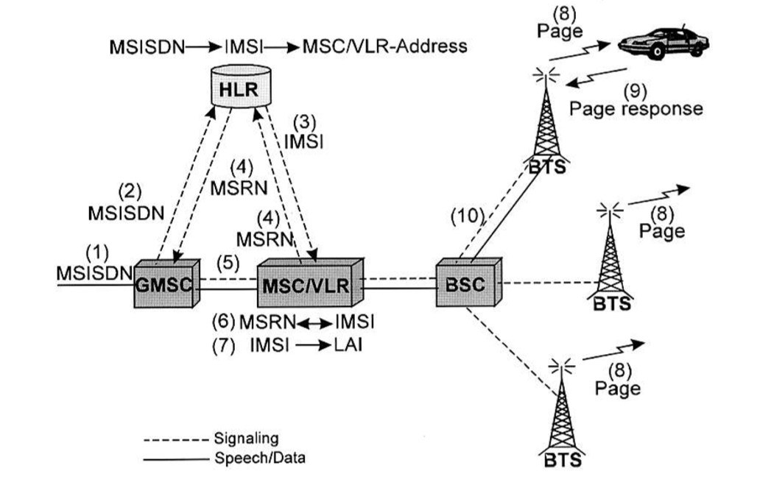

1. Call entering to GSM network is routed to the nearest GMSC
2. The GSM analyse the MSISDN[9] to find the HLR (subscriber registered in)

* The MSC/VLR address is stored in HLR
* The IMSI (International Mobile Subscriber Identity) is stored in HLR

1. The HLR send request to an MSRN (Mobile Station Roaming Number) to the MSC/VLR included in the message the IMSI
2. The MSRN is returned via HLR to the GMSC
3. The GMSC routes the call to the MSC/VLR by MSRN
4. The MSC/VLR retrieve the Ms’s IMSI
5. Using IMSI MSC identifies LA
6. The MS is paged in cells in the LA
7. MS responds authentication, cipher mode setting, IMEI (International Mobile Equipment Identity) check are carried out
8. Traffic channel connected from MSC to BSC and the BTS

# 24. What are the steps call from MS?

1. Call start with signalling channel using RACH (Random Access Channel)
2. MS indicates request, IMSI (International Mobile Subscriber Identity) analyzed, MS marked busy in the VLR
3. Authentication is performed by MSC
4. Ciphering is initiated, IMEI (International Mobile Equipment Identity) validated
5. MSC receives a setup message from MS (including B number)
6. Link established between MSC and BSC to assign traffic channel
7. Call confirmation
8. Call accepted

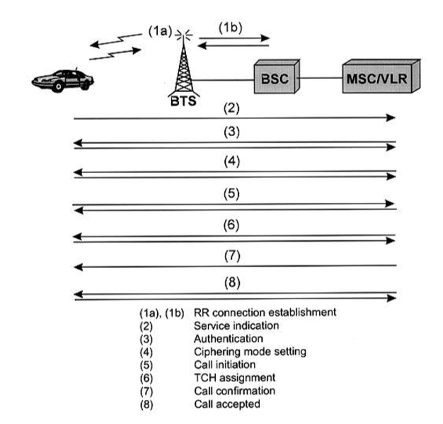

# 25. What is the function of a private network?

* **Closed user group, special purpose network**
  + Railway, transport, pipeline, fleet
  + Water management, energy systems, emergency services, police networks
  + Company-wide networks (MOL, OTP)
  + Global company networks (Coca-Cola)
* **Common features:**
  + Internal numbering schemes, addressing system
  + Strictly regulated gateway function for interconnection to other (public) networks
  + The transmission part of networks might be leased line or own connection (radio)
  + The multiplexing, switching, management, authentication processes are private functions
  + Task oriented service quality parameters (reliability, usability, error rate, response time, redundancy, backup time etc.)
  + Separated frequency management (“governmental” use)

# 26. What are the function and structure of a CATV network?

* **Cable television (CATV)** is a system of delivering television programming to consumers via radio frequency signals transmitted through coaxial cables, or in more recent systems, light pulses through fiber-optic cables.
* This contrasts with broadcast television (also known as terrestrial television), in which the television signal is transmitted over the air by radio waves and received by a television antenna attached to the television; or satellite television, in which the television signal is transmitted by a communications satellite orbiting the Earth and received by a satellite dish on the roof.
* FM radio programming, high-speed Internet, telephone services, and similar non-television services may also be provided through these cables.
* **Topologies:** string, tap-off, star
* **Main characteristics of CATV systemsµ**
  + Traditional AM VSB TV sets
  + Set top boxes for receiving DVB[10] programs (including demodulator, MPEG decoder and some sort of descramblers)
  + Internal frequency plan with 8 MHz raster (free assignment of programs to 8 MHz channels)
  + Low split system: from 5 MHz up to 55 (50, 68) MHz for the uplink path from 70 (87) MHz up to 630 MHz for the analogue downlink path and 630 - 862 MHz for digital downling path
  + 8 TV and 8 radio channel is one 8 MHz channel (in the digital channels)
  + The nominal impedance at all connection points of CATV system is 75 ohms

# 27. MPEG-2 principles

* MPEG-2 is a standard for "the generic coding of moving pictures and associated audio information".
* MPEG-2 is widely used as the format of digital television signals that are broadcast by terrestrial (over-the-air), cable, and direct broadcast satellite TV systems.
* **Principles:**
  + **Intra-coding** relies on two characteristics of typical images:
    - Not all spatial frequencies are simultaneously present
    - The higher is the spatial frequency the lower the amplitude is likely to be.
    - Requires analysis of the spatial frequencies.
    - Divide the picture into tiles[11], and if neighboring colors are similar enough we take the average color and compress the image.
  + **Inter-coding** relies on finding similarities between successive pictures.
    - The next picture can be created by sending only the picture differences.
    - We can check even further images and scan the differences.
    - The shifting process is controlled by pair of horizontal and vertical displacement values (collectively known as the motion vector) that is transmitted to the decoder.
    - The motion vector transmission requires less data than sending the picture-difference data.
* **Structure:**
  + Hierarchy: Sequence, Group of Pictures, Picture, Slice, Macroblock, Block

# 28. What is the MPEG stream and transport stream?

* **MPEG streams**:
  + **Elementary stream** is an endless near real-time signal.
  + **Program streams** have variable-length packets with headers.
  + **Transport stream**: PES packets are subdivided into short fixed-size packets and multiple programs can be carried in the same stream.

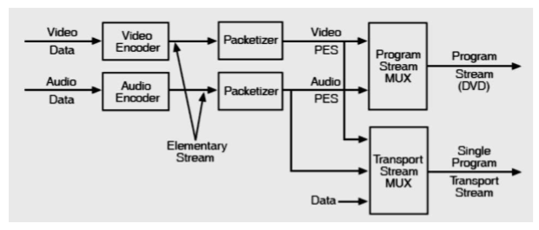

# 29. What is the structure of the HUNGARNET network? Why?

* Private network for research and academic community and part of EU GEANT project.
* **Services:** HBONE (Backbone network of NIIF), ADSL, registration service, email, web hosting, web page, ftp etc.
* Operated by NIIF (Nemzeti Információs Infrastruktúra Fejlesztési Program)
* Cutting edge technologies: IPv6
* 40 GB/s speed
* Hybrid network structure
* IP/MPLS[12] layer - more complex network needs
* DWDM[13] layer - special network needs
* <https://conference.niif.hu/event/5/session/7/contribution/127/material/slides/1.pdf>

# 30. Which technologies and structures are applied in the networks of ITK building?

* The ICT[14] is not the part of the building, but the topic of the education program.
* We need a building that is capable of implementing any kind of new technologies.
* The lifetime of a network technology is about 10 years, while the lifetime of the building is around 100.
* **Planning principles:**
  + 1000 computers and 100 telephones in the network
  + Fast error free and reliable operation
  + Popular test bed for system suppliers, no disturbing in outlook
* **Consequences:**
  + Robust, multi-path external connections, meshed topology, load sharing operation
  + Copper, optical, radio technologies in internal and external links
  + Over dimensioned and accessible duct system

# 31. Principles of ADSL, Technology of ADSL, features of ADSL, VDSL

* **Asymmetric Digital Subscriber Line (ADSL) principles**
  + A modem technology
  + Convert existing twisted-pair telephone lines into access for multimedia and high speed data communication
  + Can transmit to 30 Mb/s downstream (VDSL 100 Mb/s)
  + Transform the existing PSTN[15] network to a powerful system capable of bringing multimedia, full motion video to the subscriber’s home
* **Technology of ADSL**
  + No ultimate technology!
  + Frequency division multiplexing, time division multiplexing, modulation, error control, flow control, scrambling, adaptation, handshaking, etc.
  + More room for further development

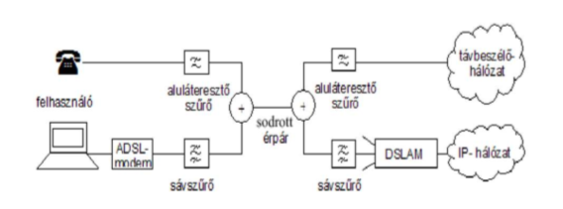

* **Very-High-Bit-Rate Digital Subscriber Line (VDSL)** is a digital subscriber line (DSL) technology providing data transmission faster than ADSL over a single flat untwisted or twisted pair of copper wires, and on coaxial cable.
  + Frequency band from 25 kHz - 12 MHz
  + Capable of supporting applications over a single connection (high-definition television, telephone services, internet access)
  + VDSL is deployed over existing wiring used for analog telephone service, and lower-speed DSL connections

# 32. What are the main service quality requirements in different services?

* **Voice, music, video**
  + Sensitive on delay (max. 300 ms)
  + Sensitive on jitter[16] (max. 30 ms)
  + Sensitive on video/voice synchrony (lip-sync)
  + Error tolerant (Bit-Error-Rate 10-3)
* **Games**
  + Sensitive on delay (max. 10 ms)
  + Sensitive on error
* **Data, still picture**
  + Sensitive on error (max. 10-6)
  + Delay and jitter tolerant

# 33. What are the historical stages of regulation? What is the reason for competition instead of monopoly in electronic communication?

* **Az elektronikus hírközlés szabályozásának korszakai[17]**
  + Természetes (állami) monopólium (hatósági ár, ellátási kötelezettség, végberendezések, egységes rendszer - kevés szabályozni való)
  + Posta, távközlés, műsorszórás, hatósági területek szétválasztása
  + Magánkézbe adás, koncessziós működés a kizárólagosság - ellátási kötelezettség megtartásával és fejlesztési kötelezettséggel
  + Korlátozott verseny, új piacra lépők segítése a “kimazsolázás” lehetőségével, jelentős piaci erővel rendelkezők kötelezettségeivel (RIO-RUO), eszköz piac liberalizálása (rengeteg szabályozni való)
  + Kiegyenlített piaci viszonyok által áthatott működés
* **Competition instead of monopoly**
  + Monopolies are bad because the monopolists have no incentive to innovate or invest in R&D[18] of new technologies
  + Monopolies strangle budding companies and stop competition
  + Monopolies can control prices and quality

# 34. What are the main functions of a terminal?

* **Terminals:** In the context of telecommunications, a terminal is a device which ends a telecommunications link and is the point at which a signal enters and/or leaves a network. Examples of equipment containing network terminations are telephones, fax machines, computer terminals and network devices, printers and workstations.
  + Terminals are part of the networks but individual elements
  + No terminals = No electronic communications
  + Terminals are commerced in normal shops and supermarkets and they are owned by users.
* **Main function**
  + B (batter supply)
  + O (overload protection)
  + R (ringing)
  + S (supervision, signalling)
  + C (coding)
  + H (hybrid)
  + T (testing)

# 35. Bluetooth, ZigBee

* **Wireless Personal Access Network (WPAN)**
  + Short distance radio communication among devices
  + Distance is less than 10 meters
  + Eg. Bluetooth, ZigBee
  + Usage: Headsets, synchronization, data access points
* **Bluetooth characteristics**
  + Operates in 2.4 GHz band at a data rate of 720 Kb/s
  + Uses Frequency Hopping (FH) spread spectrum, which divides the frequency band into a number of channels
  + Radio transceivers hop from one channel to another in pseudorandom fashion, determined by the master
  + Supports up to 8 devices in a piconet (1 master, 7 slaves)
  + Piconets can combine to form scatternets
    - **Piconet:**
      * Collection of devices connected in an ad hoc[19] fashion
      * One unit will act as a master others as slaves
      * Each piconet has a unique hopping pattern/ID
      * Each master can connect to 7 simultaneous or 200+ inactive (parked) slaves per piconet
    - **Scatternet**
      * The linking of multiple co-located piconets through the sharing of common master or slave devices
      * A device can be both a master and slaves
      * High capacity system, each piconat has maximum capacity (720 Kb/s)

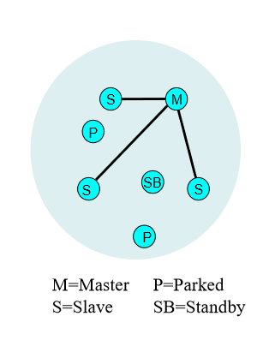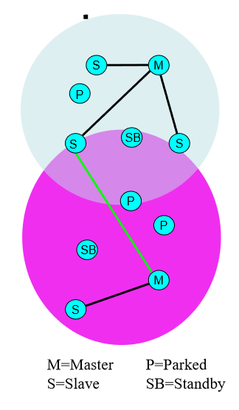

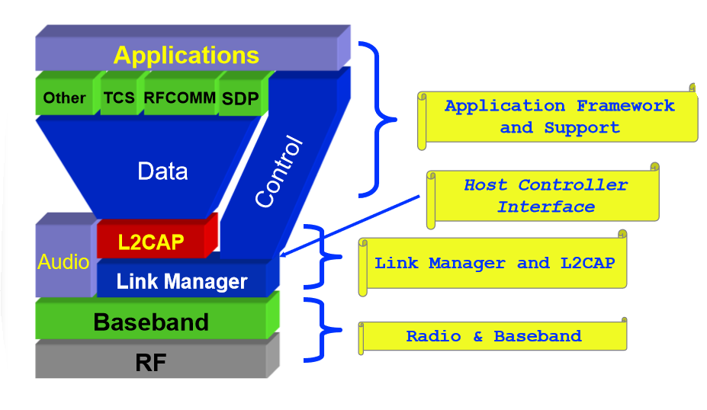

* **ZigBee**
  + Organized as an independent, neutral, nonprofit corporation in 2002
  + **Open and global**
    - Anyone can join and participate
    - Membership is global
  + **Activity includes**
    - Specification creation
    - Certification and compliance programs
    - Branding, market development, and user education
  + **Characteristics**
    - 65536 network (client) nodes
    - 27 channels over 2 bands
    - 250 Kb/s data rate
    - Optimized for timing-critical applications and power management
    - Full Mesh Networking Support
  + **Device Types:**
    - **ZigBee Coordinator (ZC)**
      * One required for each ZB network
      * Initiates network formation
    - **ZigBee Router (ZR)**
      * Participates in multi hop routing of messages
    - **ZigBee End Device (ZED)**
      * Does not allow association or routing
      * Enables very low cost solutions

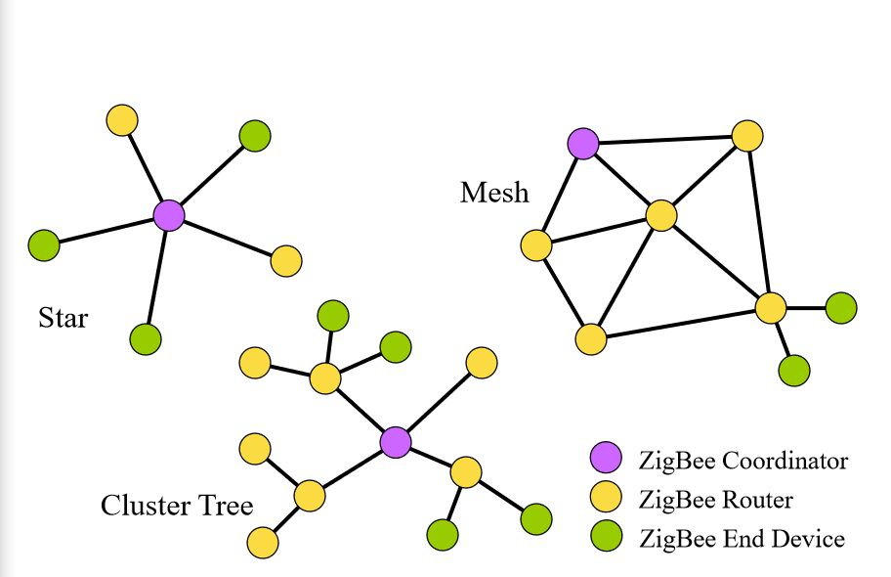

* **Application**
  + **Home Automation:** light switches, thermostats, window shade, heating unit etc.
  + **Industrial:** Plant Monitoring (Temperature, pressure sensors, infrared, etc.)

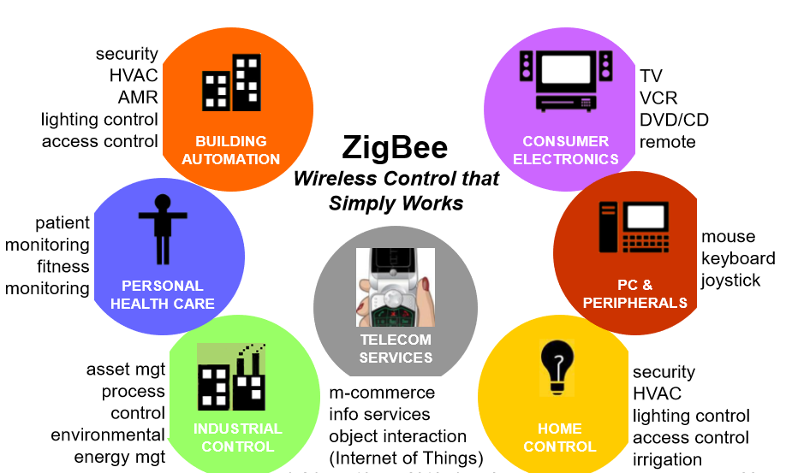

# 36. WiFi principles, media access control, frequency bands, beamforming

* **Local Area Network (LAN):** A local area network (LAN) is a computer network that interconnects computers within a limited area.
* **Radio Local Area Network (RLAN, WLAN)**: using wireless communication to form a local area network (LAN)
  + In-door communication
  + Distance: 150 meters or less
* **Wireless Fidelity (WiFi):** Commercial name of RLAN operating fit to IEEE 802.11 in frequency band 2.4 GHz or in band 5.6 GHz or 60 GHz
* Wifi using fast changing FHSS to avoid interference and fading.
* **Components of a WiFi network:**

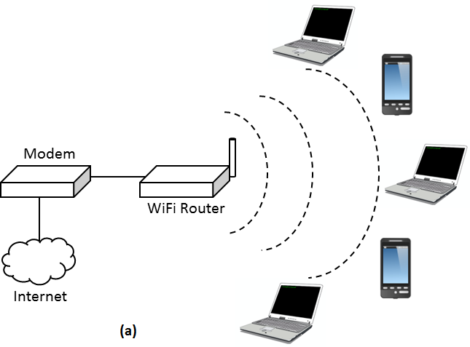

* **Collision detection**
  + We can’t use the wired Ethernet’s CSMA/CD (Carrier Sensing Media Access and Collision Detection) operation, because the devices can’t communicate with each other.
  + Collisions avoided rather than detected.
  + End device requests the WiFi Router to send a message containing a source address, destination address, duration of the transaction.
  + The transmission will only happen if the router sends a verification to the device.
  + WIFI controls all transmission, and avoids collisions.
* **Media Access Control (MAC)** sublayer and the logical link control (LLC) sublayer together make up the **data link layer**.
  + MAC is mandatory for all stations
  + MAC is to assemble data into a **frame including local address and error detection field**
  + MAC checks the frame address perform error correction on the frame, disassemble the frame and passes it to the Logical Link Control
  + The LLC identifies higher layer programs to handle the data and provides an interface to these higher layer programs while perform flow and error control
* **Beamforming** (spatial filtering) is a signal processing technique used in sensor arrays for directional signal transmission or reception.[20]
  + This is achieved by combining elements in an antenna array in such a way that signals at particular angles experience constructive interference while others experience destructive interference.
  + Beamforming can be used at both the transmitting and receiving ends in order to achieve spatial selectivity.

# 37. VoIP principles and versions

* **Voice over Internet Protocol (VoIP):** Voice over Internet Protocol (also voice over IP, VoIP or IP telephony) is a methodology and group of technologies for the delivery of voice communications and multimedia sessions over Internet Protocol (IP) networks, such as the Internet.  
  *Az internet protokoll feletti hangátvitel – elterjedt nevén VoIP, Voice over IP vagy IP-telefónia – a távközlés egy olyan formája, ahol a beszélgetés nem a hagyományos telefonhálózaton, hanem az interneten vagy más, szintén IP-alapú adathálózaton folyik. Ez tehát azt is jelenti, hogy privát VoIP kiépítése minden további nélkül lehetséges egy helyi hálózaton.*
  + Phone service over the Internet
  + If you have a reasonable quality Internet connection you can get phone service delivered through your Internet connection instead of from your local phone company.
  + Not Skype (!)
* **Key issues:**
  + Session Initiation Protocol (SIP)
  + Voice CODEC
  + Packet Loss control
* **Versions:**
  + **Cordless Hard Phones**
  + **Dial Up Hard Phones**: A dialup hard phone is a hard phone with a built-in modem instead of Ethernet port
  + **WLAN or WiFi phones**: hard phone with built-in WiFi transceiver unit instead of an Ethernet port to connect to a WiFi base station and from there to remote VoIP server
  + **Hard Phones (voice and video)**
  + **Soft Phones (voice only)**
  + **Soft Phones (voice and video)**

# 38. IPTV

* **Internet Protocol Television (IPTV)** is the delivery of television content over Internet Protocol (IP) networks.
* This is in contrast to delivery through traditional terrestrial, satellite, and cable television formats. Unlike downloaded media, IPTV offers the ability to stream the source media continuously.
* As a result, a client media player can begin playing the content (such as a TV channel) almost immediately. This is known as **streaming media.**
* IPTV is also used for media delivery around corporate and private networks.

# 39. Next generation networks

* **The next-generation network (NGN)** is a body of key architectural changes in telecommunication core and access networks.
* The general idea behind the NGN is that **one network transports all information and services** (voice, data, and all sorts of media such as video) by encapsulating these into **IP packets**, similar to those used on the Internet.
* NGNs are commonly built around the Internet Protocol, and therefore the term all IP is also sometimes used to describe **the transformation of formerly telephone-centric networks toward NGN.**
* Next-generation networks are purely based on Internet technologies including **Internet Protocol (IP)** and **multiprotocol label switching (MPLS)**.

1. Ajánlott ezen a linken a visszaverődéses jelenséget átolvasni a karakterisztikus impedanciáról, mert külön bele kérdez, hogy mitől karaktersztikus az impedancia (kér rajzot is): https://www.tankonyvtar.hu/hu/tartalom/tamop412A/2011-0035_digitalis_aramkorok_alkalmazastechnikaja/pdf/15_1.pdfattachment
2. *Mintha erre azt mondta volna a bácsi, hogy hazugság és buktat érte ha valaki ezt mondja.* ¯\_(ツ)_/¯
3. Tudd mindegyikre, hogy mi az alkalmazási terület külön-külön, hogy miért és az ábrát is.
4. https://www.youtube.com/watch?v=33Cqp6Lduj8
5. Ez így egyébként fixen nem elég, habár ennyi van a diájában ZH-ban és vizsgán is többet szeretne hallani, érdemes figyelni előadáson és alaposan utánajárni.
6. https://www.youtube.com/watch?v=tt1-Ohe9QQU
7. HLR-ről és VLR-ről bővebben a 21-es kérdésben
8. https://www.techopedia.com/definition/7580/home-location-register-hlr
9. The number uniquely identifying a subscription in a GSM or a UMTS mobile network.
10. Digital Video Broadcasting
11. Ezt a szót akarja hallani.
12. Multiprotocol Label Switching
13. Dense Wavelength-division multiplexing
14. Information and Communication Technology (InfoComm)
15. Public Switched Telephone Network (https://en.wikipedia.org/wiki/Public_switched_telephone_network)
16. https://www.elektro-net.hu/rendszerintegrator/3427-jitter-alapok
17. *Sajnos ezt angolul nem tette be a diájába, online forrást angolul nem találtam hozzá.*
18. Research and development
19. Solution designed for a specific problem or task
20. https://pcworld.hu/hardver/beamforming-erdemes-ramozdulni-160351.html